## Table 1 (Baseline characteristics)

|  |  |  |  |  |
| --- | --- | --- | --- | --- |
|  | no | yes | p | test |
| n | 798 | 370 |  |  |
| blood_loss_ml (median [IQR]) | 900.00 [700.00, 1245.00] | 1400.00 [1000.00, 2087.50] | <0.001 | nonnorm |
| blood_loss_ratio (median [IQR]) | 0.19 [0.14, 0.26] | 0.31 [0.22, 0.42] | <0.001 | nonnorm |
| oak = yes (%) | 23 (2.9) | 21 (5.7) | 0.030 |  |
| tcaggr = yes (%) | 87 (10.9) | 40 (10.8) | 1.000 |  |
| preop_hb (median [IQR]) | 135.00 [123.00, 145.00] | 120.00 [104.00, 130.75] | <0.001 | nonnorm |
| preop_tc (median [IQR]) | 251.50 [211.00, 309.00] | 267.00 [214.25, 338.75] | 0.002 | nonnorm |
| bmi (median [IQR]) | 25.56 [22.86, 28.72] | 25.40 [22.73, 28.51] | 0.710 | nonnorm |
| age (median [IQR]) | 67.08 [59.21, 74.29] | 71.05 [64.05, 77.41] | <0.001 | nonnorm |
| cci_5plus (%) |  |  | <0.001 |  |
| 0 | 304 (38.1) | 106 (28.6) |  |  |
| 1 | 131 (16.4) | 48 (13.0) |  |  |
| 2 | 181 (22.7) | 90 (24.3) |  |  |
| 3 | 98 (12.3) | 56 (15.1) |  |  |
| 4 | 55 (6.9) | 37 (10.0) |  |  |
| 5 and more | 29 (3.6) | 33 (8.9) |  |  |
| gender = female (%) | 239 (29.9) | 140 (37.8) | 0.009 |  |
| p_tumor (%) |  |  | <0.001 |  |
| 0 | 201 (25.2) | 59 (15.9) |  |  |
| 1 | 111 (13.9) | 38 (10.3) |  |  |
| 2 | 193 (24.2) | 75 (20.3) |  |  |
| 3 | 233 (29.2) | 129 (34.9) |  |  |
| 4 | 60 (7.5) | 69 (18.6) |  |  |
| p_node_pos = yes (%) | 167 (20.9) | 104 (28.1) | 0.009 |  |
| op_duration_min (median [IQR]) | 390.00 [345.00, 425.75] | 408.50 [351.00, 454.00] | <0.001 | nonnorm |
| previous_op = yes (%) | 326 (40.9) | 162 (43.8) | 0.378 |  |
| norepinephrine = yes (%) | 519 (65.0) | 203 (54.9) | 0.001 |  |
| crystalloids_mlkgh (median [IQR]) | 4.50 [3.30, 6.01] | 5.30 [3.80, 7.06] | <0.001 | nonnorm |
| neoadj_chemo = yes (%) | 101 (12.7) | 75 (20.3) | 0.001 |  |

#### Stepwise Logistic Regression

##### Coefficients

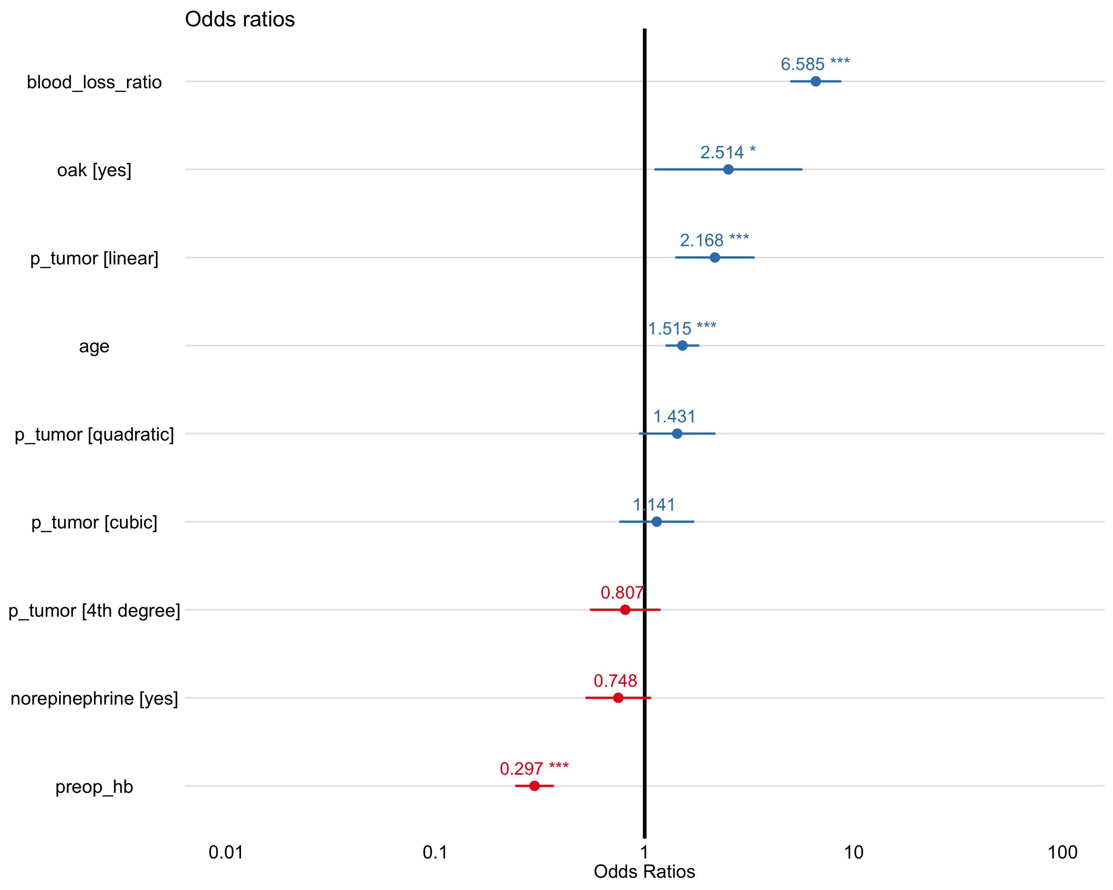

|  |  |  |  |  |  |  |
| --- | --- | --- | --- | --- | --- | --- |
| term | estimate | std.error | statistic | p.value | conf.low | conf.high |
| (Intercept) | 0.3969 | 0.1491 | -6.1960 | 0.0000 | 0.2949 | 0.5294 |
| oakyes | 2.5145 | 0.4159 | 2.2171 | 0.0266 | 1.0985 | 5.6550 |
| preop_hb | 0.2971 | 0.1083 | -11.2100 | 0.0000 | 0.2388 | 0.3652 |
| age | 1.5154 | 0.0949 | 4.3787 | 0.0000 | 1.2617 | 1.8316 |
| norepinephrineyes | 0.7476 | 0.1845 | -1.5770 | 0.1148 | 0.5207 | 1.0740 |
| p_tumor.L | 2.1679 | 0.2229 | 3.4712 | 0.0005 | 1.4032 | 3.3660 |
| p_tumor.Q | 1.4311 | 0.2149 | 1.6684 | 0.0952 | 0.9394 | 2.1831 |
| p_tumor.C | 1.1414 | 0.2105 | 0.6285 | 0.5297 | 0.7525 | 1.7194 |
| p_tumor^4 | 0.8068 | 0.1984 | -1.0821 | 0.2792 | 0.5461 | 1.1902 |
| blood_loss_ratio | 6.5846 | 0.1437 | 13.1201 | 0.0000 | 5.0131 | 8.8088 |

##### Estimated marginal means

|  |  |  |  |  |  |  |  |
| --- | --- | --- | --- | --- | --- | --- | --- |
| term | contrast | null.value | odds.ratio | std.error | df | z.ratio | adj.p.value |
| p_tumor | 1 / 0 | 0 | 1.2350 | 0.3960 | Inf | 0.6583 | 0.9186 |
| p_tumor | 2 / 1 | 0 | 0.8258 | 0.2602 | Inf | -0.6075 | 0.9371 |
| p_tumor | 3 / 2 | 0 | 1.6710 | 0.4088 | Inf | 2.0988 | 0.1239 |
| p_tumor | 4 / 3 | 0 | 1.6977 | 0.4871 | Inf | 1.8446 | 0.2133 |
| term | contrast | null.value | odds.ratio | std.error | df | z.ratio | adj.p.value |
| p_tumor | 0|1 | 0 | 1.5786 | 0.3549 | Inf | 2.0306 | 0.1259 |
| p_tumor | 1|2 | 0 | 1.5417 | 0.3067 | Inf | 2.1760 | 0.0907 |
| p_tumor | 2|3 | 0 | 2.0562 | 0.4005 | Inf | 3.7008 | 0.0007 |
| p_tumor | 3|4 | 0 | 2.3903 | 0.6410 | Inf | 3.2496 | 0.0040 |

##### 

##### Binned residuals

#> Warning: About 94% of the residuals are inside the error bounds (~95% or higher would be good).

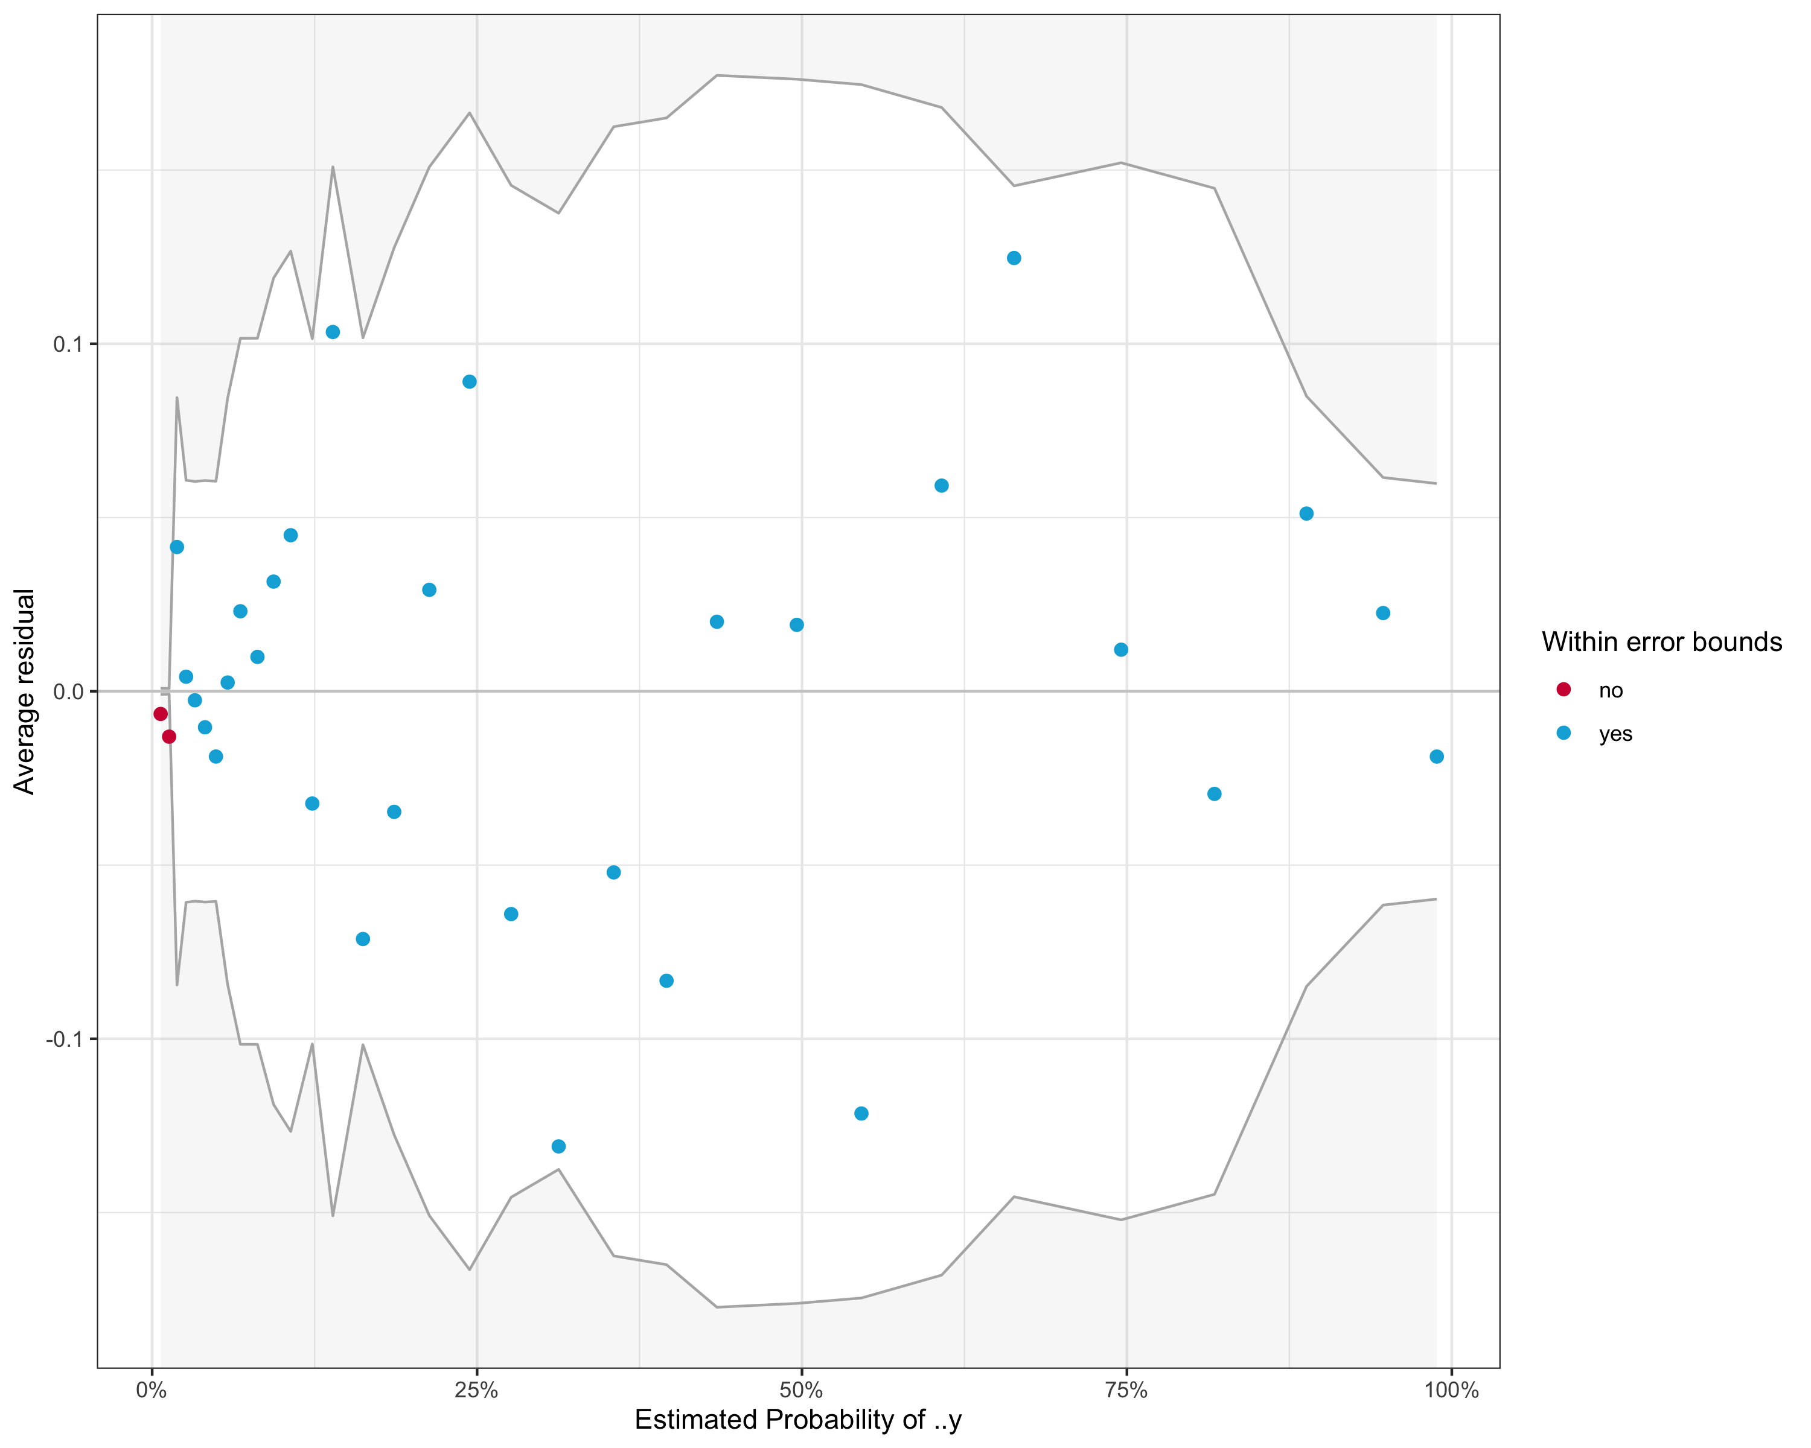

##### Variance inflation factor

#> GVIF Df GVIF^(1/(2*Df))  
#> oak 1.031610 1 1.015682  
#> preop_hb 1.252277 1 1.119052  
#> age 1.070004 1 1.034410  
#> norepinephrine 1.071535 1 1.035150  
#> p_tumor 1.096664 4 1.011601  
#> blood_loss_ratio 1.342430 1 1.158633

#### Model performance

|  |  |  |  |  |  |
| --- | --- | --- | --- | --- | --- |
| Model | Recall | Precision | F1 | Accuracy | AUC |
| Stepwise Logistic Regression | 0.722 | 0.667 | 0.693 | 0.800 | 0.859 |
| Random Forest | 0.667 | 0.649 | 0.658 | 0.783 | 0.858 |
| Elastic Net Logistic Regression | 0.722 | 0.650 | 0.684 | 0.791 | 0.853 |
| Support Vector Machine | 0.722 | 0.650 | 0.684 | 0.791 | 0.852 |

#### Optimal cutpoint

Optimal probability threshold by absolute distance to optimal model (sensitivity and specificity = 1

|  |  |  |  |  |
| --- | --- | --- | --- | --- |
| Model | Threshold | Sensitivity | Specificity | Distance |
| Stepwise Logistic Regression | 0.3201714 | 0.7923708 | 0.7908440 | 0.0082724 |
| Elastic Net Logistic Regression | 0.3174359 | 0.7930836 | 0.7918560 | 0.0091146 |
| Support Vector Machine | 0.3149697 | 0.7945120 | 0.7951261 | 0.0092939 |
| Random Forest | 0.3494245 | 0.7849229 | 0.7846765 | 0.0131046 |